Here’s a **complete, in-depth explanation of GPU** in the context of **Parallel and Distributed Computing**, with examples, architecture, and applications.

**GPU: Parallel & Distributed Computing**

**1. Definition of GPU**

A **GPU (Graphics Processing Unit)** is a **specialized processor designed for performing large-scale, highly parallel computations**, originally for graphics rendering but now widely used for general-purpose computing (GPGPU).

**Exam-ready one-line definition:**

**A GPU is a specialized processor optimized for parallel processing, capable of executing thousands of threads simultaneously, making it ideal for high-performance and distributed computing tasks.**

**2. Why GPU is Important**

* CPUs have **few cores optimized for sequential tasks**.
* GPUs have **thousands of cores optimized for parallel tasks**.
* Ideal for:
  + Scientific simulations
  + Data analytics
  + Machine learning
  + Image/video processing

**Key Idea:** GPU accelerates tasks that can be **broken into thousands of small, independent computations**.

**3. GPU vs CPU**

| **Feature** | **CPU** | **GPU** |
| --- | --- | --- |
| Cores | Few (4–32) | Thousands |
| Optimization | Sequential processing | Parallel processing |
| Clock Speed | High | Moderate |
| Memory | Cache-based, small | High-bandwidth memory (VRAM) |
| Example Tasks | OS, web browsing | Matrix multiplication, ML, simulations |

**4. GPU Architecture**

**4.1 Core Components**

1. **Streaming Multiprocessors (SMs):**
   * Each SM contains multiple cores.
   * Executes multiple threads simultaneously.
2. **Global Memory:**
   * Accessible by all SMs.
   * High capacity, moderate speed.
3. **Shared Memory:**
   * Local to each SM.
   * Very fast, used for inter-thread communication.
4. **Registers:**
   * Fastest memory per thread.
5. **Warp / Thread Blocks:**
   * Threads organized into **blocks**.
   * Blocks organized into **grids**.

**4.2 Parallel Execution Model**

* GPU uses **SIMD (Single Instruction, Multiple Data)** model.
* Executes the **same instruction across multiple threads** simultaneously.
* Ideal for **data-parallel tasks**.

**5. GPU in Parallel & Distributed Computing**

**5.1 Parallel Computing**

* Break computation into thousands of threads.
* Each thread computes a small part of the task.
* Example: Matrix multiplication, vector addition.

**5.2 Distributed Computing**

* Multiple GPUs can work together across nodes.
* Example: GPU clusters for training deep learning models.
* Communication via frameworks like **NCCL, MPI, or CUDA-aware MPI**.

**6. GPU Programming Examples**

**6.1 CUDA (NVIDIA GPU)**

**Vector Addition Example in CUDA (C++)**

#include <cuda_runtime.h>

#include <stdio.h>

__global__ void vectorAdd**(int** **\***a**,** **int** **\***b**,** **int** **\***c**,** **int** n**){**

**int** i **=** blockDim**.***x* **\*** blockIdx**.***x* **+** threadIdx**.***x***;**

**if(**i **<** n**){**

c**[**i**]** **=** a**[**i**]** **+** b**[**i**];**

**}**

**}**

**int** main**(){**

**int** n **=** 1024**;**

**int** size **=** n **\*** sizeof**(int);**

**int** **\***a**,** **\***b**,** **\***c**;**

cudaMallocManaged**(&**a**,** size**);**

cudaMallocManaged**(&**b**,** size**);**

cudaMallocManaged**(&**c**,** size**);**

**for(int** i**=**0**;**i**<**n**;**i**++){**

a**[**i**]** **=** i**;**

b**[**i**]** **=** i**\***2**;**

**}**

vectorAdd**<<<(**n**+**255**)/**256**,** 256**>>>(**a**,** b**,** c**,** n**);**

cudaDeviceSynchronize**();**

printf**(**"Result[0] = %d\n"**,** c**[**0**]);**

cudaFree**(**a**);** cudaFree**(**b**);** cudaFree**(**c**);**

**return** 0**;**

**}**

**Explanation:**

* __global__ → function executed on GPU.
* Threads are organized in **blocks**.
* GPU executes **thousands of threads in parallel**.

**6.2 Python Example (PyTorch)**

**import** torch

# Create tensors on GPU

a **=** torch**.***randn***(**1000**,** device**=**'cuda'**)**

b **=** torch**.***randn***(**1000**,** device**=**'cuda'**)**

# Parallel vector addition on GPU

c **=** a **+** b

**print(**c**[:**5**])**

* Automatically uses GPU cores for parallel computation.
* Ideal for ML, simulations, and scientific computing.

**7. Advantages of GPU**

* Massive parallelism → thousands of threads
* High throughput for vector/matrix operations
* Ideal for **data-parallel workloads**
* Accelerates ML, AI, simulations, graphics

**8. Limitations of GPU**

* Not good for sequential tasks
* High power consumption
* Memory size is limited compared to CPU
* Requires specialized programming (CUDA, OpenCL, etc.)

**9. GPU vs CPU vs TPU**

| **Feature** | **CPU** | **GPU** | **TPU** |
| --- | --- | --- | --- |
| Cores | Few | Thousands | Thousands (ML optimized) |
| Best For | Sequential tasks | Parallel data tasks | Matrix operations / Deep learning |
| Memory | General RAM | VRAM | High bandwidth memory |
| Example | OS, apps | ML, simulations | TensorFlow training |

**10. GPU in Distributed Systems**

* Multi-GPU nodes connected via **NVLink / PCIe**
* Clusters communicate via **MPI or NCCL**
* Example: **Distributed deep learning training**:
  + Each GPU computes gradients on a data shard
  + Gradients aggregated across nodes
  + Model updated in parallel

**11. GPU Use Cases in Parallel & Distributed Computing**

* Deep learning / AI training (TensorFlow, PyTorch)
* Scientific simulations (weather, molecular modeling)
* Image/video processing
* Big data analytics
* Cryptocurrency mining

**12. GPU vs Hadoop / AWS / OpenStack / Condor**

| **Feature** | **GPU** | **Hadoop** | **AWS** | **OpenStack** | **Condor** |
| --- | --- | --- | --- | --- | --- |
| Type | Processor | Framework | Cloud | Cloud | Job scheduler |
| Parallelism | Thread-level parallelism | MapReduce tasks | EC2/Lambda tasks | VMs, containers | Independent tasks |
| Distributed | Multi-GPU clusters | Across cluster nodes | Across regions | Across nodes | Across idle machines |
| Fault Tolerance | Via software frameworks | Built-in replication | Multi-zone | Multi-zone replication | Job migration |

**13. Exam-Oriented Summary**

**Keywords:**

* GPU, parallel cores, SIMD, CUDA, VRAM, thread blocks, multi-GPU cluster

**One-Paragraph Answer:**

A GPU is a specialized processor designed for highly parallel computations, capable of executing thousands of threads simultaneously. It is widely used in parallel and distributed computing for scientific simulations, machine learning, and big data processing. GPUs are organized into cores, thread blocks, and grids, supporting SIMD execution. Multiple GPUs can be clustered for distributed tasks, achieving high throughput and scalability.

The Central Processing Unit (CPU) and Graphics Processing Unit (GPU) serve different purposes and are optimized for specific tasks.

**CPU (Central Processing Unit):**  
The CPU is designed for general-purpose tasks and can handle a variety of different processes. It excels at sequential processing, such as calculating a single matrix quickly. You can think of the CPU like a smartphone—it is capable of performing many different tasks but is not specialized for high-end production work.

**GPU (Graphics Processing Unit):**  
The GPU, on the other hand, is designed for specific, graphics-related tasks like gaming. It is optimized for parallel processing, meaning it contains many cores that can perform independent calculations simultaneously. This makes the GPU better suited for tasks that involve repeated, similar calculations, such as rendering pixels in games where values continuously change and are recalculated. An analogy for a GPU is a professional cinema camera built for high-quality video production, unlike a smartphone. Demonstrations from Nvidia show that a GPU can paint images much faster than a CPU due to its parallel processing capabilities.

**CPU vs. GPU Interchangeability:**  
CPUs and GPUs cannot currently be used interchangeably because of compatibility issues with motherboards and other peripherals. Even though it is theoretically possible with redesigned hardware, it would be highly inefficient, as a CPU would perform poorly as a GPU and vice versa.

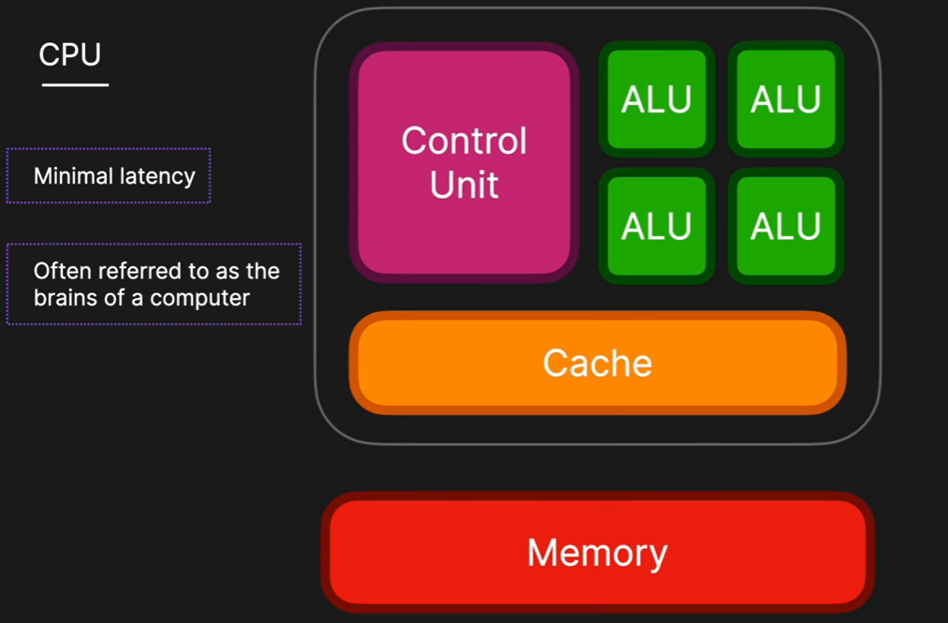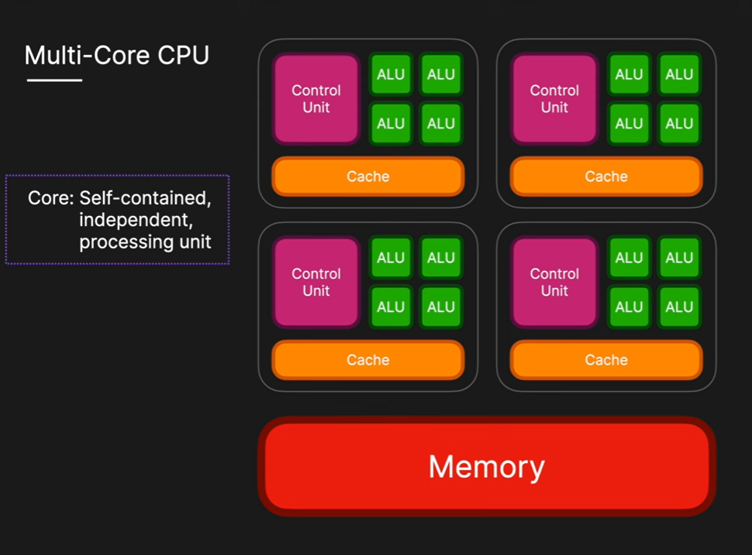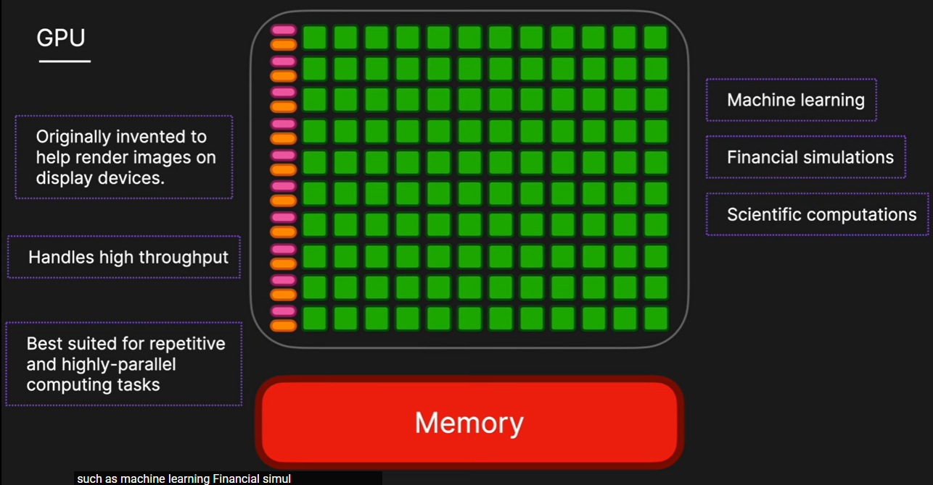

|  |  |  |  |
| --- | --- | --- | --- |
| **Feature** | **CPU (Central Processing Unit)** | **GPU (Graphics Processing Unit)** | **Similarities** |
| **Definition / Role** | The core computational unit in a server or computer. Handles all types of computing tasks required for operating systems and applications. | A specialized hardware component designed to efficiently handle complex mathematical operations that run in parallel. | Both are hardware units that make a computer work and are often considered the "brain" of a computing device. |
| **Purpose / Origin** | General-purpose computing; required to run essential software tasks. | Created to offload compute-intensive workloads like graphics and animation from CPUs, especially for parallel processing. | Both perform computations and logical operations. |
| **Processing** | Excels at sequential processing; handles a wide variety of tasks. | Excels at parallel processing; breaks repetitive tasks into smaller components to process simultaneously. | Both have cores that execute computations and logical functions. |
| **Cores** | Multi-core CPUs exist today (initially single-core). | Multi-core GPUs designed for thousands of parallel computations. | Both have cores to perform computations. |
| **Memory** | Uses internal memory (cache) to improve performance and access data quickly. | Uses internal memory (cache) for fast data access and processing efficiency. | Both utilize internal memory to speed up processing. |
| **Control Unit** | Synchronizes processing tasks and determines processing speed through electric pulse frequency. | Synchronizes processing tasks and contributes to high-speed parallel computations. | Both have control units to manage and coordinate tasks. |
| **Workloads** | General-purpose; runs operating systems, applications, and standard computing tasks. | Compute-intensive workloads like graphics, AI, and machine learning. | Both are essential for computing performance in their respective roles. |
| **Dependency** | A computer cannot operate without a CPU. | Supports the CPU by handling parallel computations. | Both are integral hardware components of a computer system. |

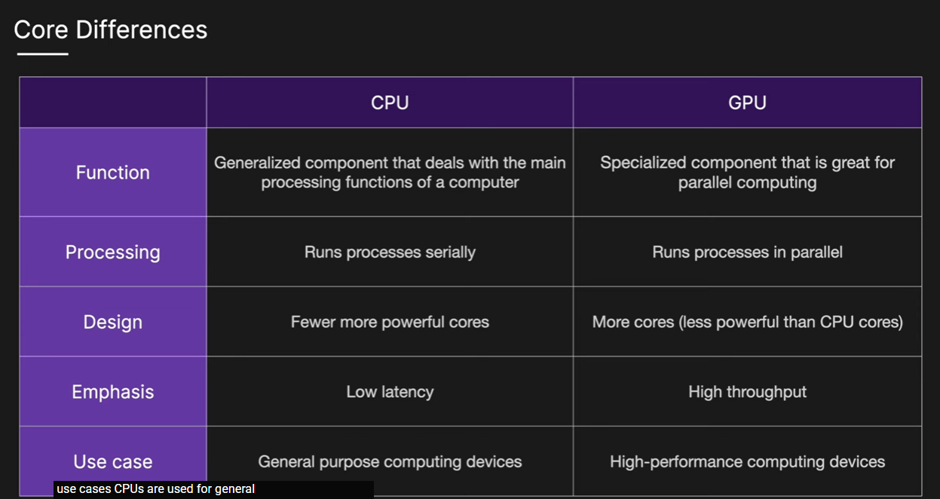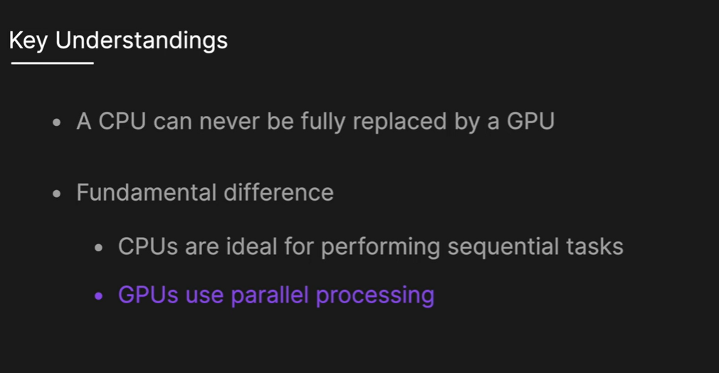

### Comprehensive Overview of How Graphics Cards Work

**Computational Power of Graphics Cards**  
Modern graphics cards perform an immense number of calculations. For example, the NVIDIA 3090 can execute around 36 trillion calculations per second, which illustrates the vast computational power of these devices.

**GPU vs. CPU Differences**  
GPUs and CPUs are designed for different purposes. A GPU can be thought of as a cargo ship—it performs massive numbers of calculations across large datasets at a slower rate. In contrast, a CPU is like a jumbo jet—it processes smaller amounts of data faster and is more flexible for running operating systems and various applications.

**GPU GA102 Architecture**  
The GA102 GPU, found in NVIDIA’s 30-series graphics cards, has a hierarchical architecture. It consists of Graphics Processing Clusters (GPCs), Streaming Multiprocessors (SMs), warps, CUDA cores, tensor cores, and ray tracing cores, each organized to efficiently handle complex computational tasks.

**GPU Manufacturing and Binning**  
Different graphics card models, such as the 3080 and 3090, can use the same GA102 chip design. This is achieved through a process called "binning," where chips with manufacturing defects have certain areas deactivated, leading to variations in core counts and overall performance between models.

**CUDA Core Design**  
A CUDA core performs fundamental operations such as fused multiply and add (FMA), which are essential for graphics rendering. Each CUDA core is carefully designed to execute these operations efficiently across large datasets.

**Graphics Card Components**  
Beyond the GPU itself, graphics cards include essential components such as the printed circuit board (PCB), display ports, power connectors, PCIe interface, voltage regulator module, and a heat sink system for cooling.

**Graphics Memory (GDDR6X & GDDR7)**  
Graphics memory is critical for feeding data to the GPU. The GDDR6X SDRAM in the 3090 continuously supplies terabytes of data, while the newer GDDR7 memory uses multi-voltage level encoding schemes (PAM3) to further increase data transfer rates.

**Micron's Role in Memory Innovation**  
Micron contributes to advancements in memory technology, producing High Bandwidth Memory (HBM) like HBM3E, which is especially important for AI-focused chips.

**Computational Architecture: SIMD and SIMT**  
GPUs handle "embarrassingly parallel" problems using computational principles like Single Instruction Multiple Data (SIMD) and Single Instruction Multiple Threads (SIMT). SIMD applies the same instruction to large amounts of data, ideal for video game rendering, while SIMT allows individual threads to progress at different rates, providing greater flexibility.

**Bitcoin Mining with GPUs**  
GPUs were initially used for Bitcoin mining because they efficiently executed thousands of iterations of the SHA-256 hashing algorithm, taking advantage of their parallel processing capability.

**Tensor Cores for AI and Neural Networks**  
Tensor cores are specialized GPU cores designed for matrix multiplication and addition, operations that are fundamental to neural networks and generative AI.

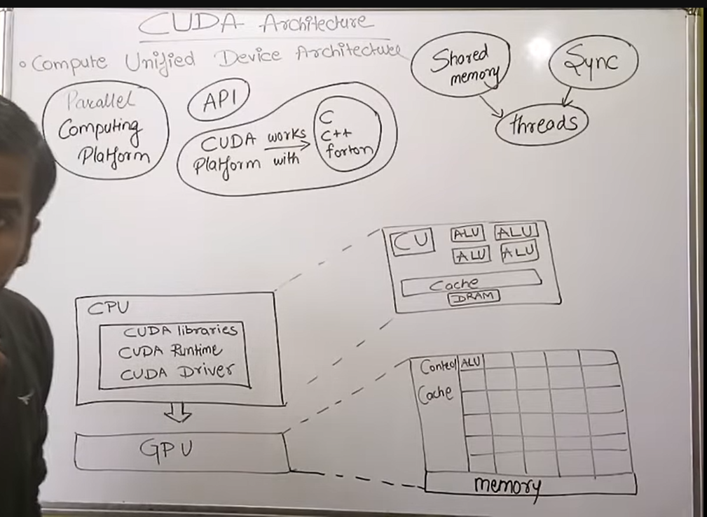

### Accelerator-Based Computing and GPU Applications

Accelerator-based computing focuses on improving application performance by using specialized hardware or software, with GPUs being a primary example. The approach builds on concepts from parallel and distributed computing, including sequential programming and multi-core CPU architectures. While multi-core CPUs increased computational power, they faced limitations due to memory bottlenecks and communication overhead between threads, leading to diminishing returns in speedup.

**Accelerators**  
Accelerators are designed to handle computationally intensive parts of an application, offloading these tasks from the CPU. Common types of accelerators include GPUs, FPGAs, and DSPs. In a heterogeneous system, the CPU handles sequential tasks efficiently, while the GPU processes parallel tasks using its numerous cores. This combination leverages the strengths of both types of processors.

**GPU Advantages**  
GPUs provide significantly higher computational performance than CPUs for parallelizable applications. Examples include:

* **Vector Addition:** GPUs perform these operations much faster than CPUs, even when accounting for communication overhead.
* **Matrix Multiplication:** As matrix sizes grow, GPUs show a greater performance advantage over CPUs.
* **Planet and Particle Simulations:** GPUs provide massive speedups compared to CPUs due to their parallel processing capabilities.

**Applications**  
Due to their high performance, GPUs are widely used in supercomputers and are highly recommended for graphics-intensive applications, video games, and machine learning models that require processing large datasets.

**Future Work**  
Programming these accelerators involves specialized libraries and directives such as CUDA and OpenACC, which enable developers to efficiently harness GPU power for high-performance computing tasks. 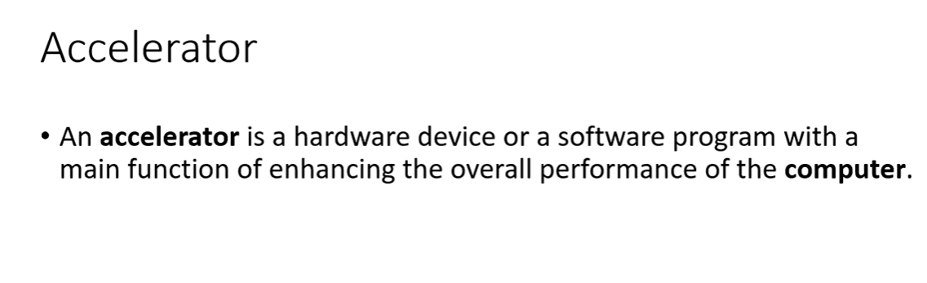

### Understanding GPUs and Their Functionality

**What is a GPU?**  
A GPU (Graphics Processing Unit) is a specialized electronic circuit designed to rapidly manipulate and alter memory to accelerate image creation for display. GPUs are typically placed on a video card and include their own dedicated memory.

**Why GPUs Are Needed**  
Conventional CPUs often struggle with high-intensity graphics applications, such as modern video games and HD movies, due to the massive number of pixels and frames that must be processed. Graphics can be raster-based, where images lose clarity when zoomed, or vector-based, where images maintain clarity through rule-based definitions. Modern applications increasingly use vector graphics, which demand more computational power.

**Processing Requirements for Graphics**  
High-intensity graphics require immense processing capabilities beyond what even advanced CPUs can provide. Shader programs, which use specialized programming languages, define and transform objects, vertices, and pixels within an image. GPUs are essential for applications where **high throughput**—the ability to process many data units simultaneously—is more critical than latency.

**CPU vs. GPU**

* **CPU:** Contains a few cores optimized to reduce instruction latency. CPUs are excellent for serial processing and managing data dependencies.
* **GPU:** Contains hundreds to thousands of simpler cores focused on high throughput. GPUs excel at parallel processing, breaking jobs into independent tasks. Most programs use both CPU and GPU code, with the CPU offloading parallelizable tasks to the GPU.

**Flynn's Classification of Computer Architectures**  
Flynn's taxonomy categorizes architectures based on instruction and data streams:

* **SISD (Single Instruction, Single Data):** Conventional uniprocessors.
* **MISD (Multiple Instruction, Single Data):** Rarely used.
* **SIMD (Single Instruction, Multiple Data):** Vector processors perform the same operation on many data items.
* **MIMD (Multiple Instruction, Multiple Data):** Multi-core computers that execute multiple instructions on multiple datasets concurrently.

**Exploiting Parallelism and SIMT**  
GPUs primarily operate using the **SIMT (Single Instruction, Multiple Threads)** model, which extends SIMD with multi-threading. In SIMT, each thread executes the same code but on a different piece of data. Sequential loops, such as matrix addition, can be vectorized so that independent iterations run in parallel, taking advantage of the GPU’s architecture.

**Warp and Fine-Grained Multi-Threading**  
A warp is a group of threads, typically 32, that execute the same instruction and are dynamically grouped by the GPU hardware. GPUs use warp-level, fine-grained multi-threading to interleave the execution of multiple warps on the same pipeline. This maximizes utilization of functional units and enables efficient parallel processing of numerous data elements, such as pixels during image transformations.

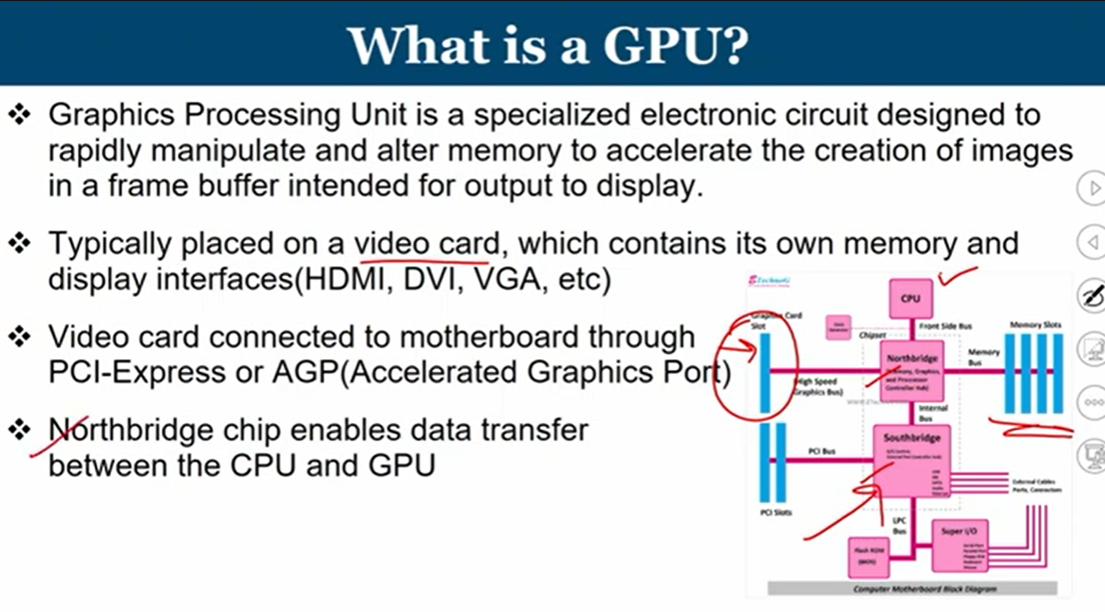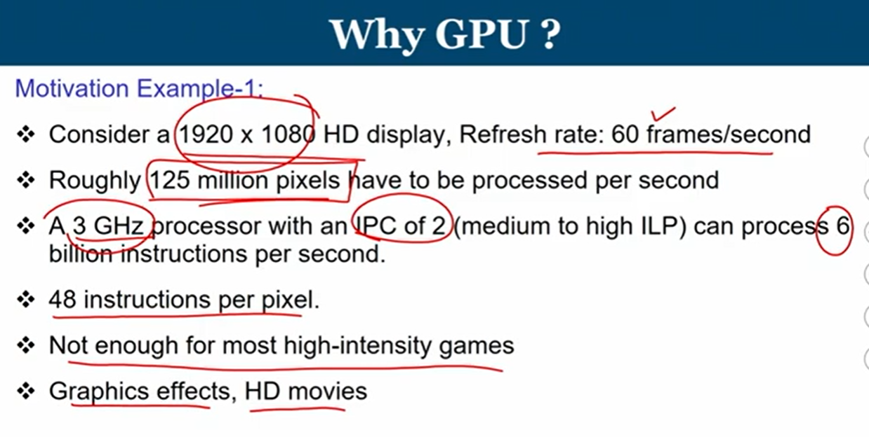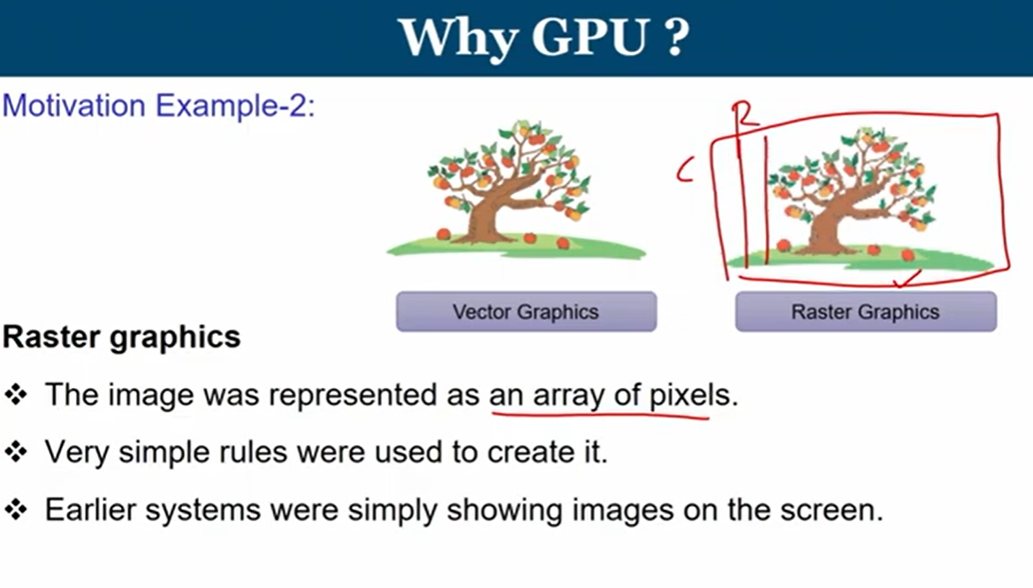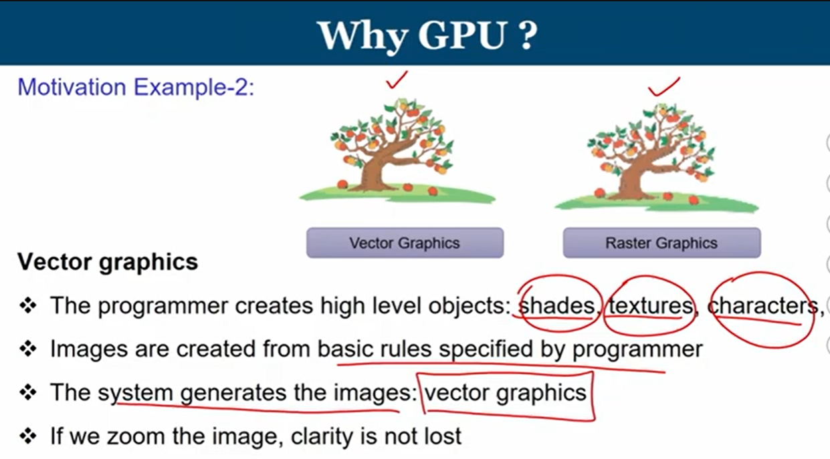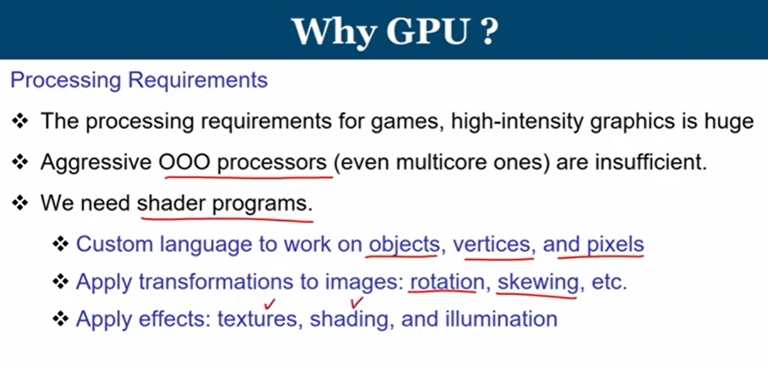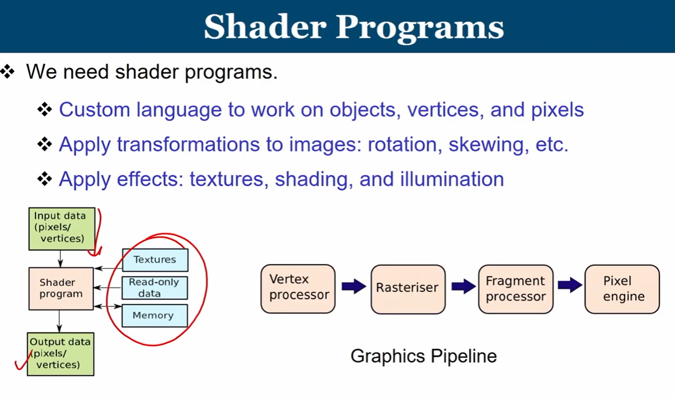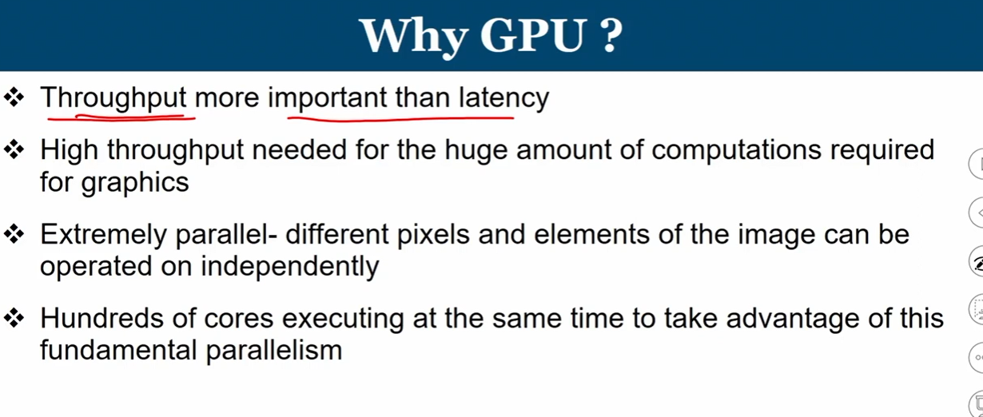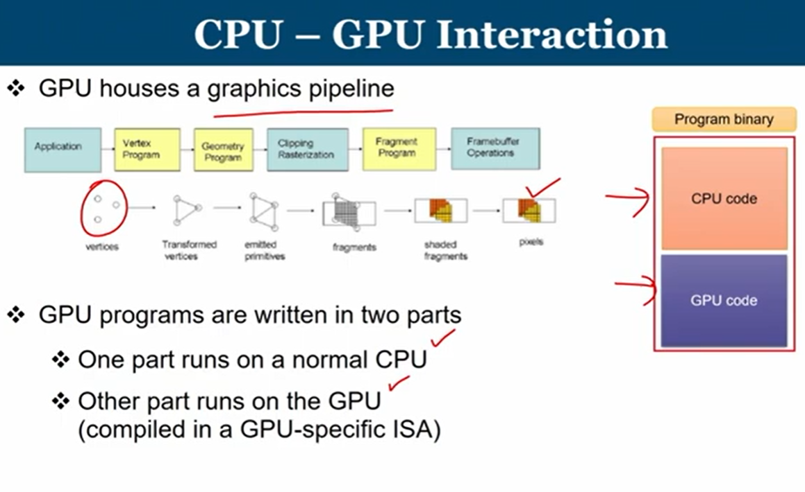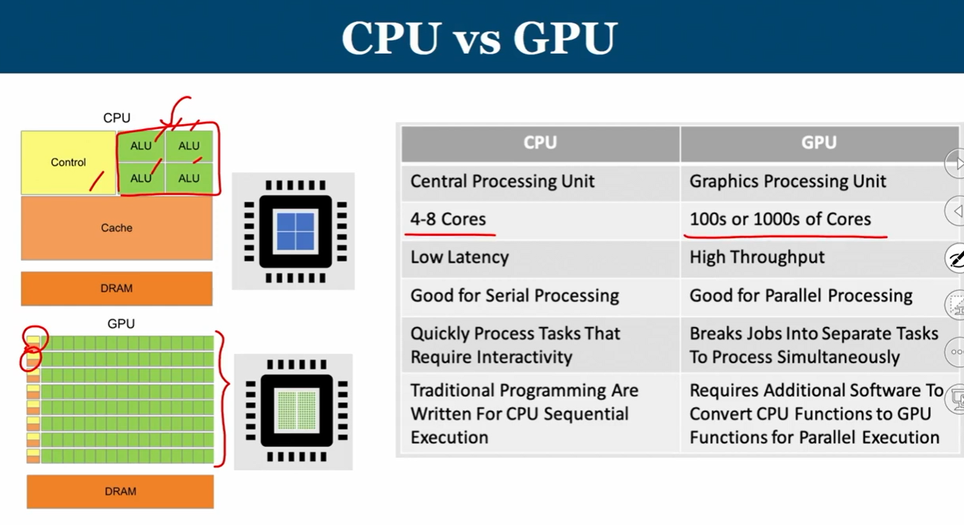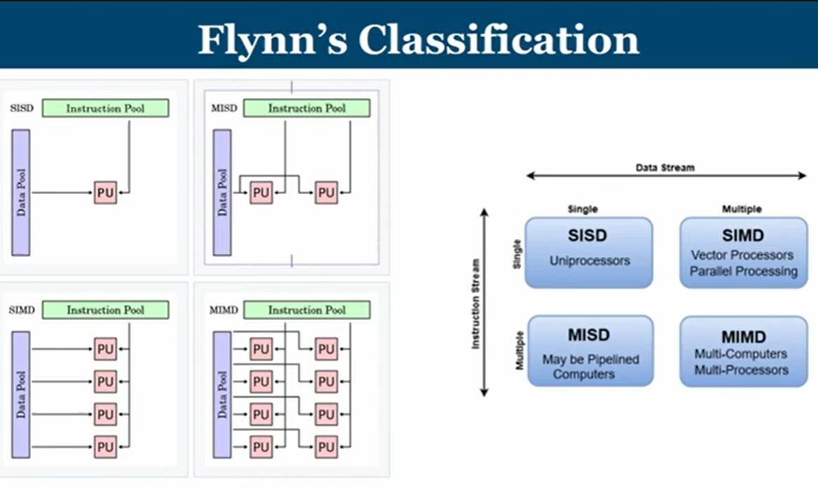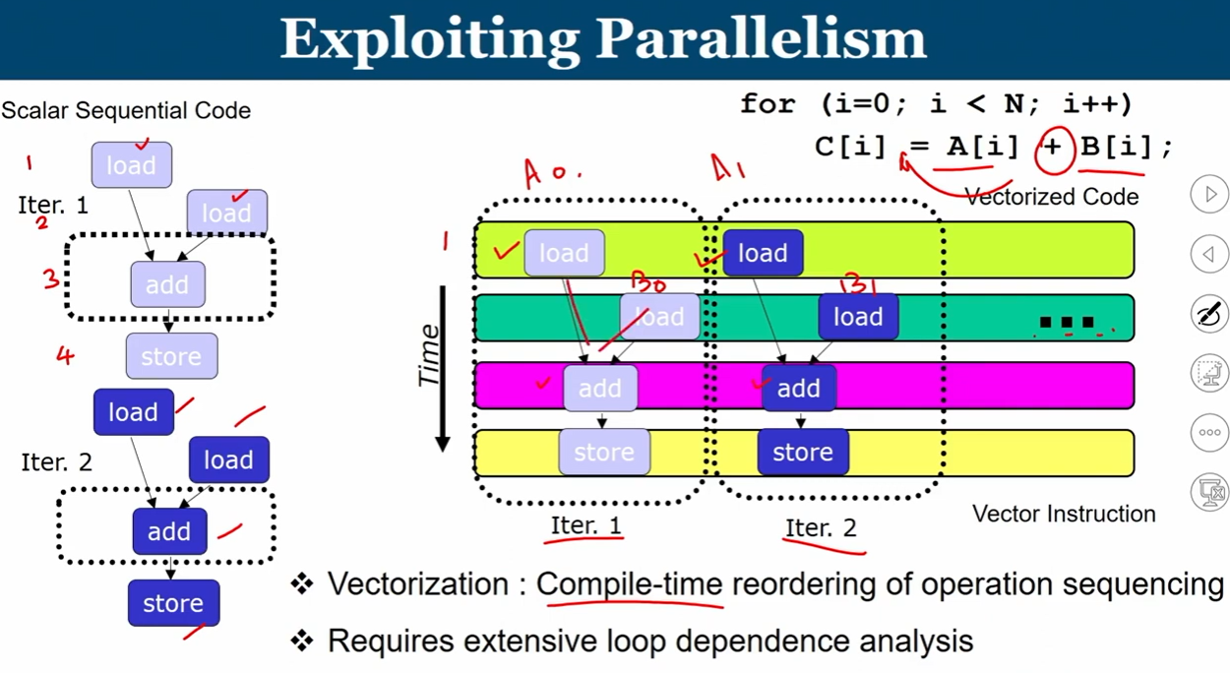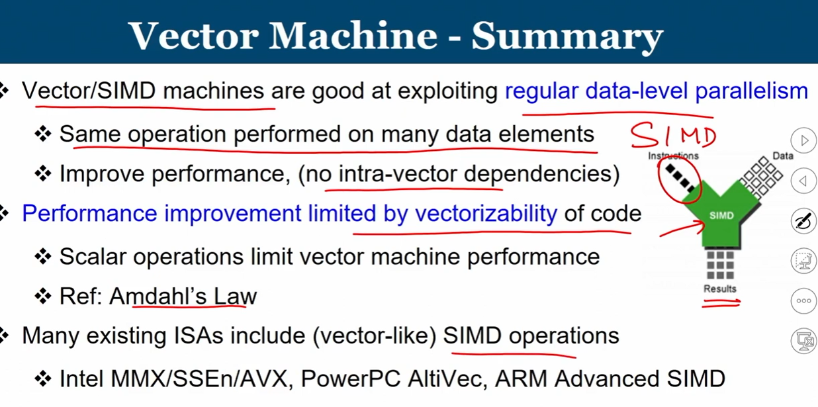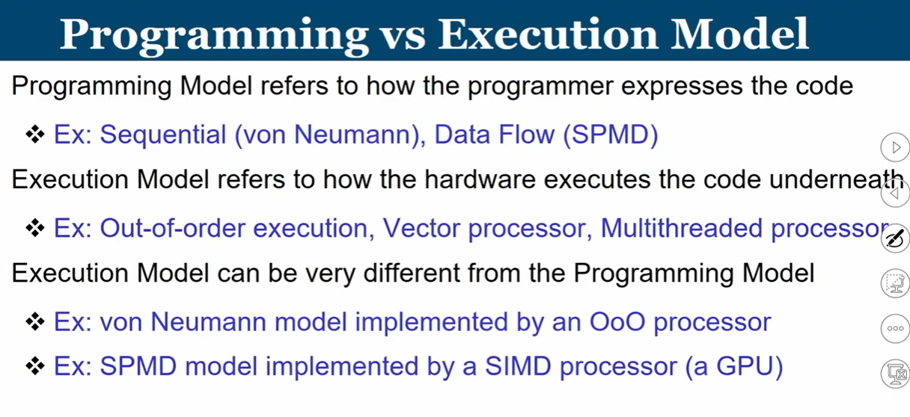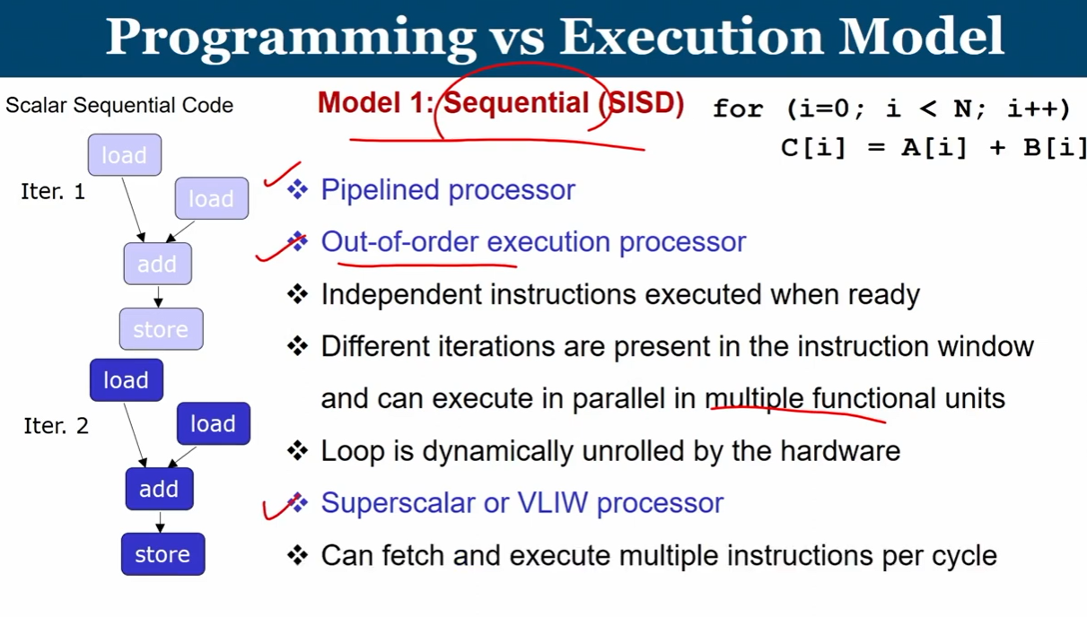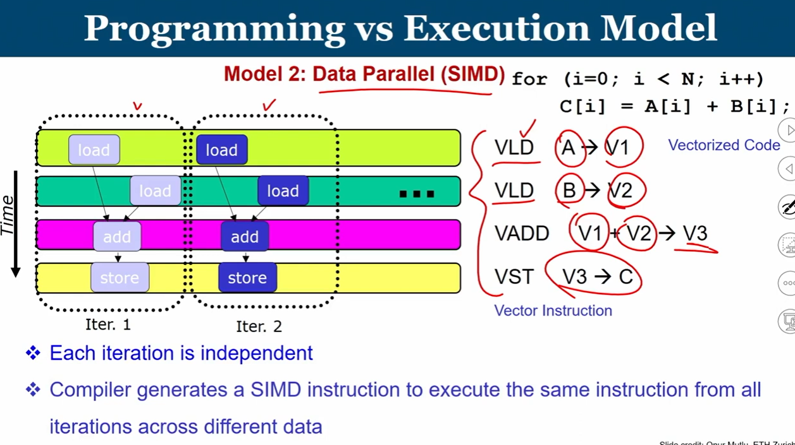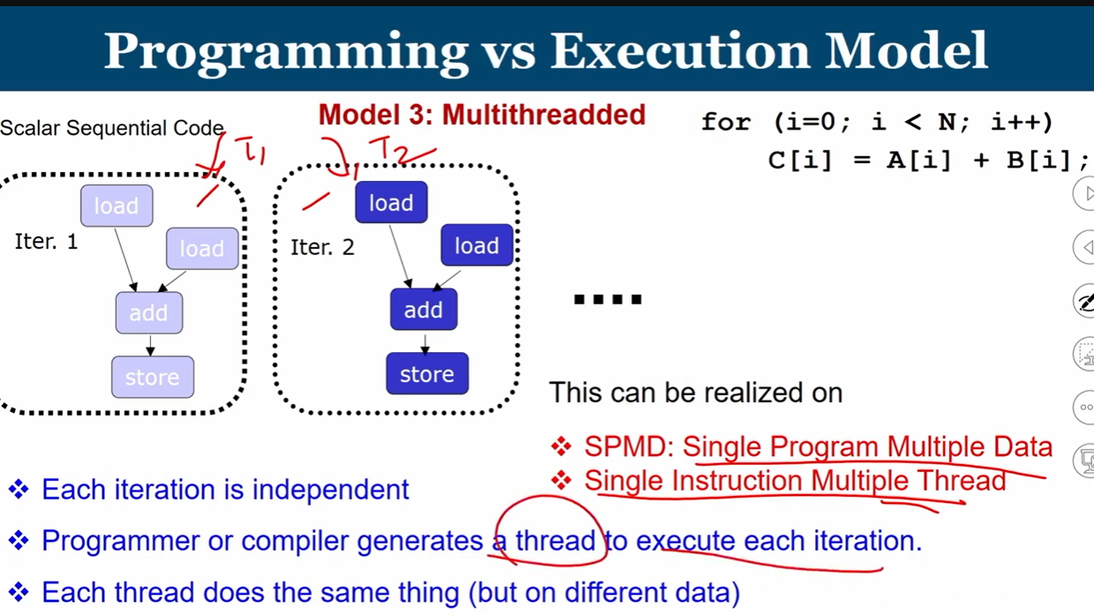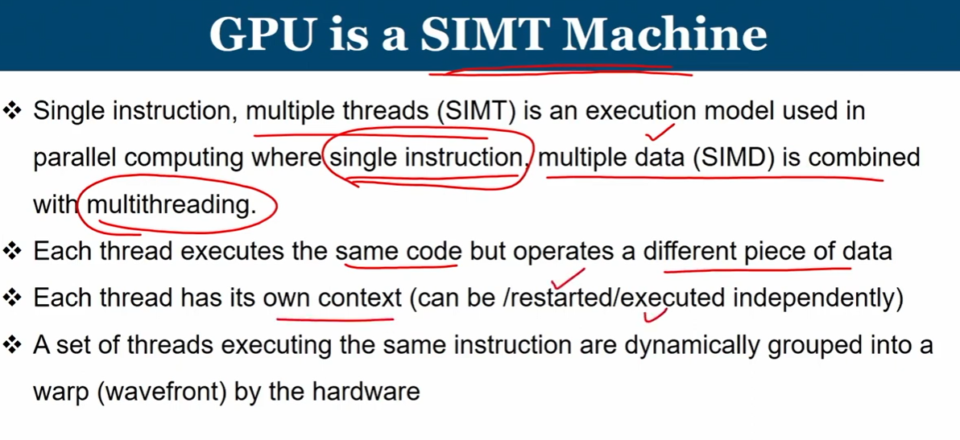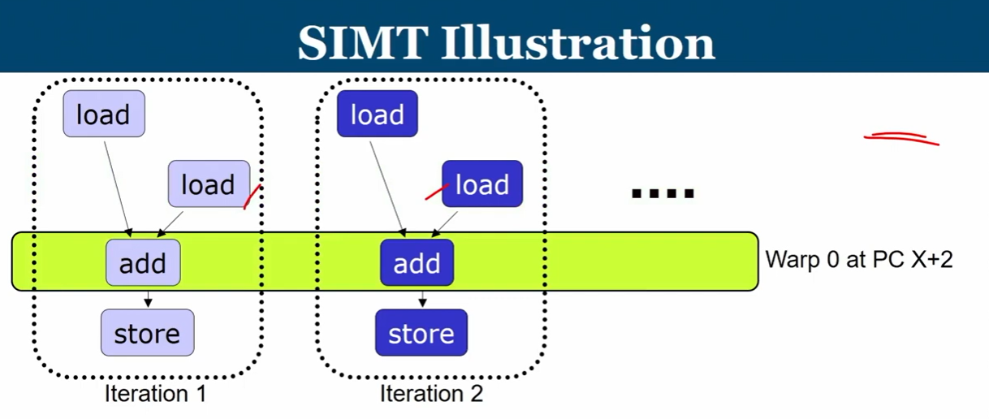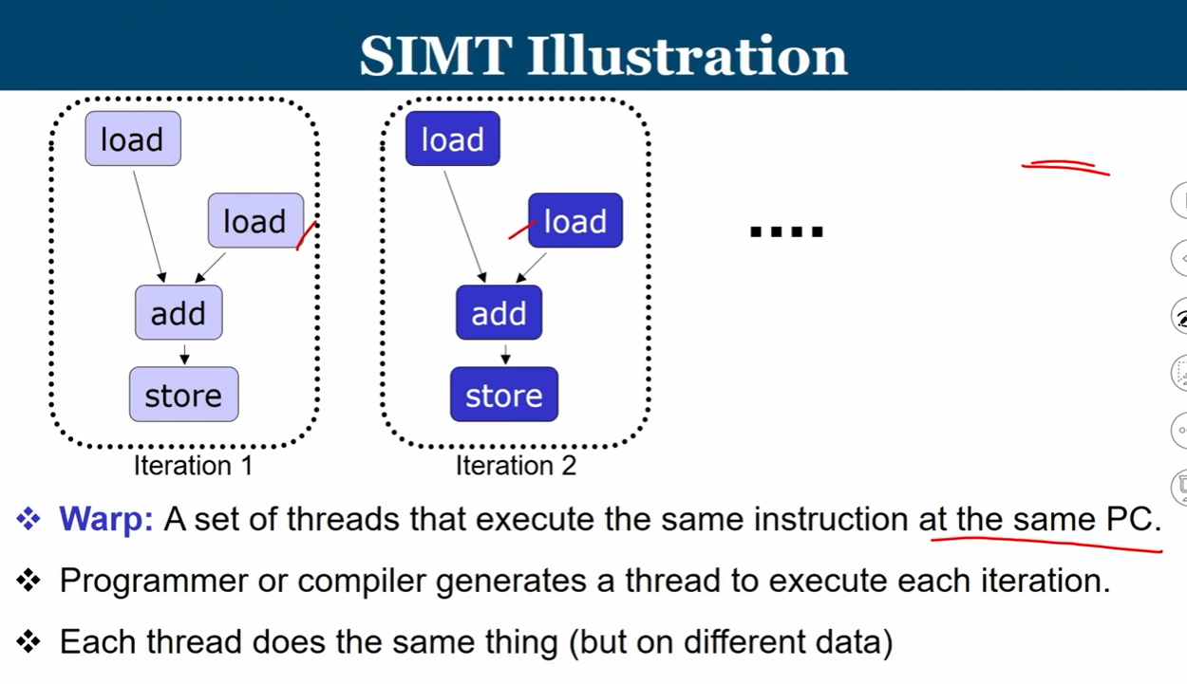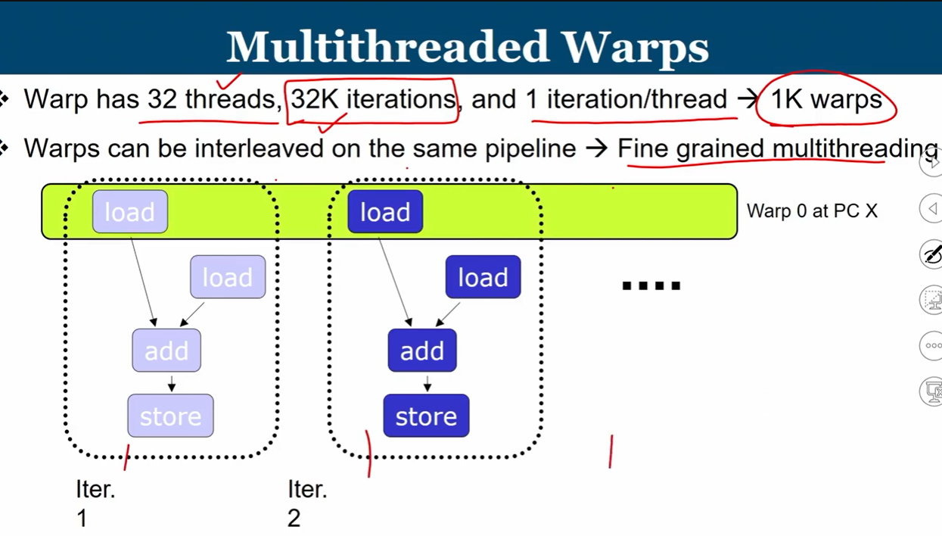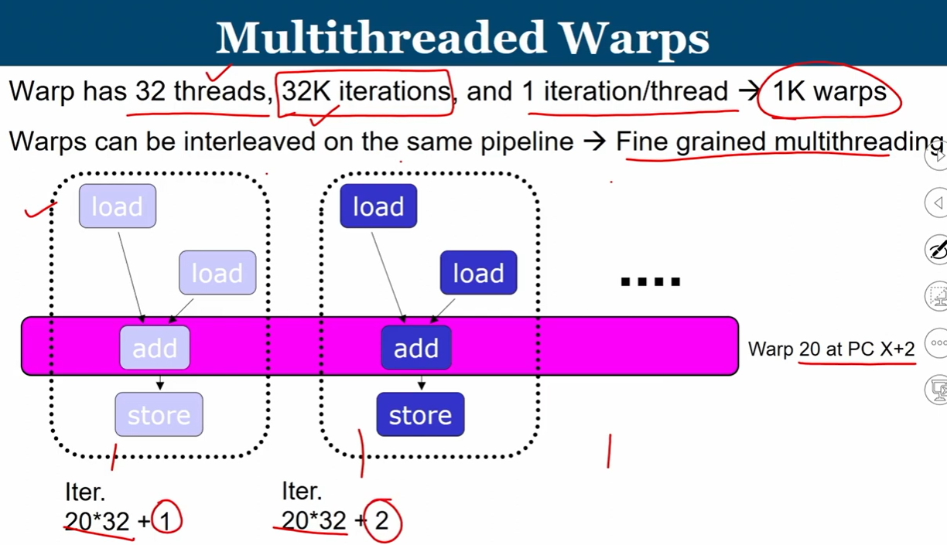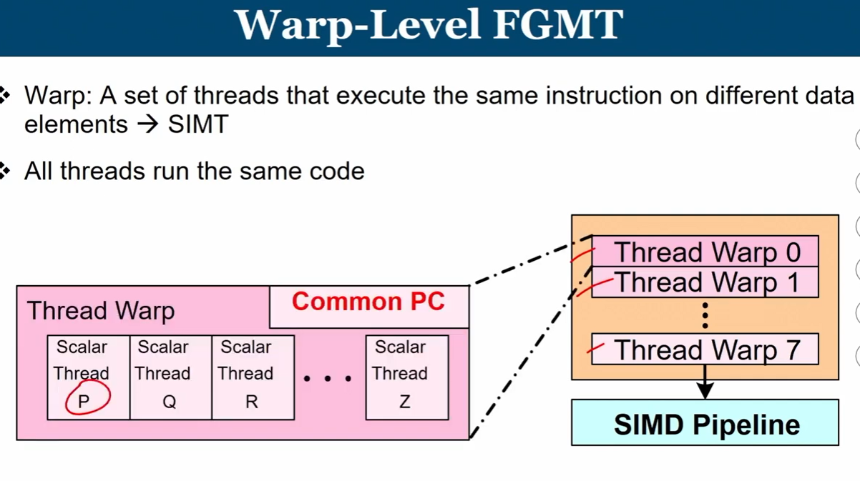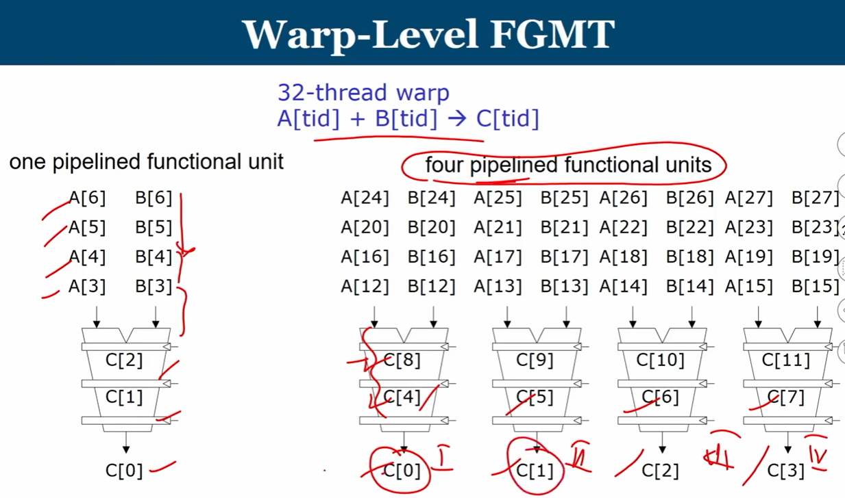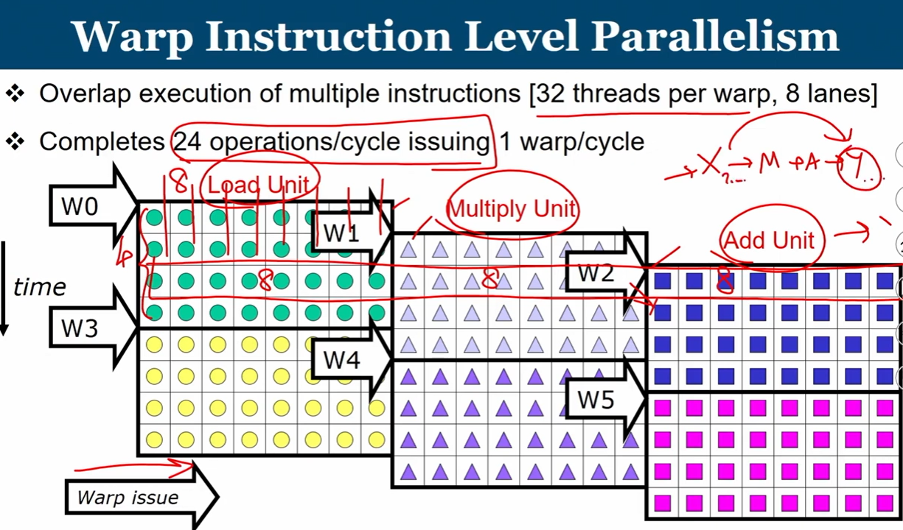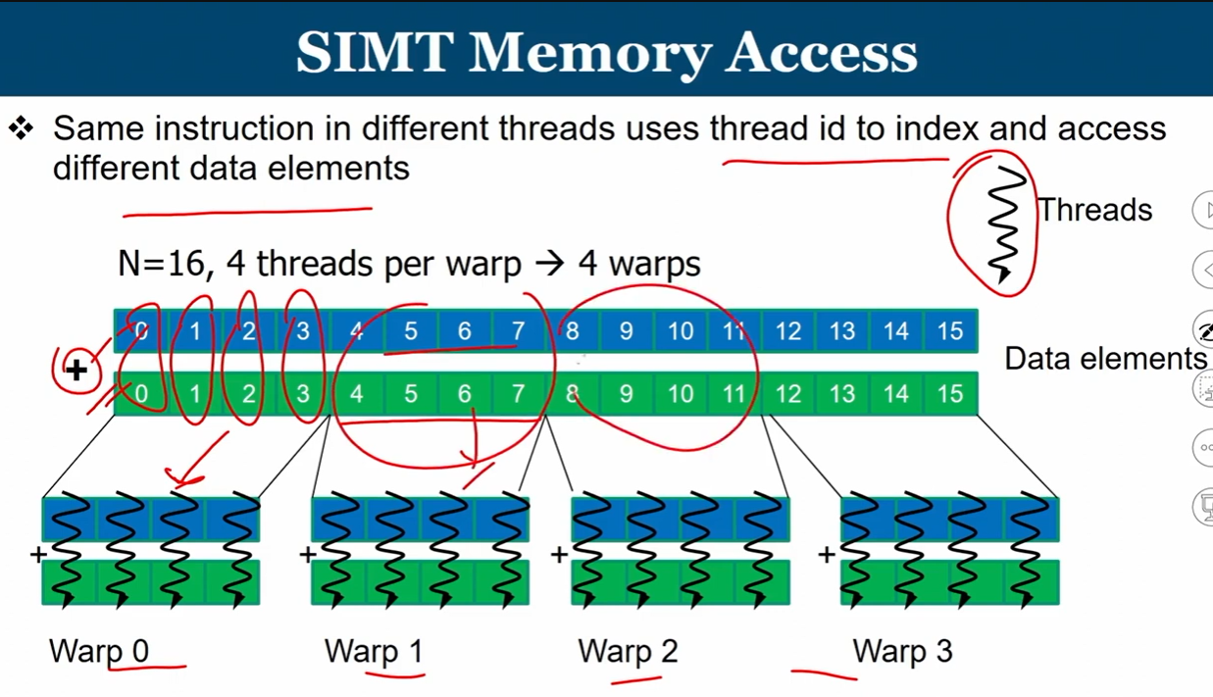

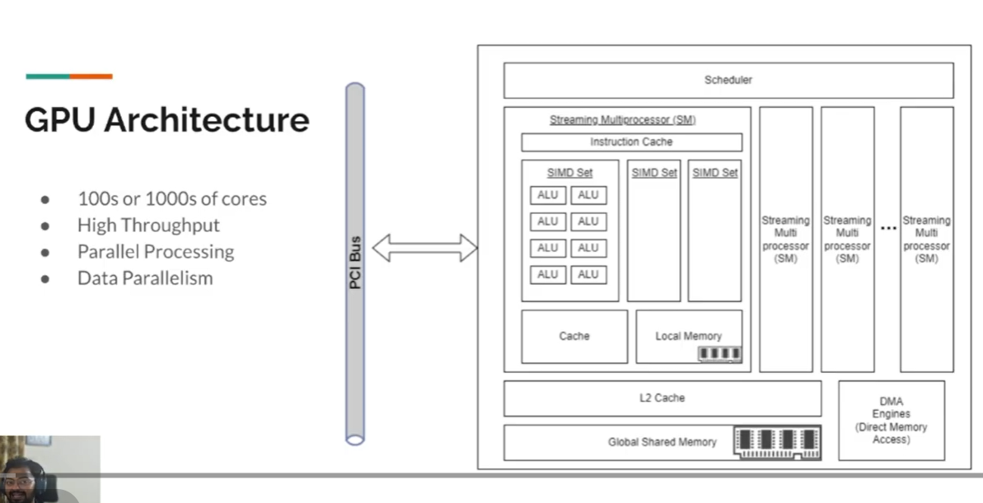

### NVIDIA CUDA and GPU Programming

**What is CUDA?**  
CUDA (Compute Unified Device Architecture) is a parallel computing platform developed by NVIDIA in 2007. It allows GPUs to perform general-purpose computations beyond graphics rendering, enabling the parallel processing of large datasets. CUDA has been crucial for advancements in artificial intelligence, deep learning, and scientific computing.

**CPU vs. GPU in CUDA**  
CPUs are designed for versatility, with relatively few cores optimized for serial processing and low-latency tasks. GPUs, on the other hand, contain hundreds to thousands of cores, optimized for high-throughput parallel operations, such as matrix multiplication and vector transformations. In CUDA, the CPU is referred to as the **host**, and the GPU as the **device**. The host executes control-intensive, sequential code, while the device handles computation-intensive tasks involving large datasets in parallel. Together, they form a **heterogeneous architecture**, leveraging the strengths of both processors.

**How CUDA Works**  
Developers write **CUDA kernels**, which are functions executed on the GPU. Data is copied from main memory (RAM) to GPU memory. The CPU instructs the GPU to execute the kernel in parallel, organizing threads into a multi-dimensional grid. Once execution completes, results are copied back to the main memory.

Key concepts in CUDA programming include:

* **cudaDeviceSynchronize()**: Pauses CPU execution until all previously launched GPU kernels complete.
* **Modular Programming with Multiple Kernels**: Different kernels can be launched to perform distinct tasks efficiently.
* **GPU Streams and Parallel Execution**: Multiple streams allow kernels to execute concurrently on the GPU, potentially leading to non-deterministic execution order.
* **Race Conditions**: Occur when multiple kernels access shared memory concurrently in different streams. Serial execution in Stream Zero avoids race conditions.

**GPU Architecture**  
GPU architecture is optimized for data parallelism, unlike CPUs, which are better for task parallelism. Key components include:

* **PCIe Connection**: Connects GPU to the host system.
* **Scheduler**: Assigns tasks to GPU cores.
* **Direct Memory Access (DMA) Engine**: Facilitates direct transfer of data between host and GPU memory.
* **L2 Cache**: Stores data for fast access by cores.
* **Streaming Multiprocessors (SMs)**: The core building blocks of GPUs. SMs are called **CUDA Cores** in NVIDIA GPUs, **Xe Cores** in Intel GPUs, and **Compute Units** in AMD GPUs.
* **Execution Within SMs**: Each SM contains multiple SIMD units and ALUs, enabling multiple threads to run in parallel.
* **Job Scheduling**: The scheduler manages task allocation to SMs, each of which has local memory and cache to optimize performance.

**GPU Programming Model**

* **SIMT (Single Instruction, Multiple Threads)**: Combines SIMD with multithreading. Each thread executes the same instruction on a different piece of data.
* **Warps and Fine-Grained Multithreading**: A warp is a group of threads (commonly 32) executing the same instruction simultaneously. GPUs interleave multiple warps on the same pipeline to maximize utilization of functional units, allowing efficient processing of data elements like pixels in graphics transformations.

**Practical Example**  
CUDA can be implemented in C++ or Python (e.g., using CuPy). Kernels are launched with configuration syntax specifying the number of blocks and threads. Developers calculate each thread's global index to handle portions of data in parallel. Synchronization ensures correct execution order and prevents race conditions.

**Applications**  
CUDA-enabled GPUs are widely used in AI, deep learning, graphics-intensive applications, games, and scientific computing, where large datasets and parallel computations are common. The heterogeneous CPU-GPU architecture ensures that both sequential and parallel workloads are efficiently handled.

